1. A parallel-plate capacitor has circular plates of 8.20 cm radius and 1.30 mm separation.

(a) Calculate the capacitance. (b) Find the charge for a potential difference of 120 V. •

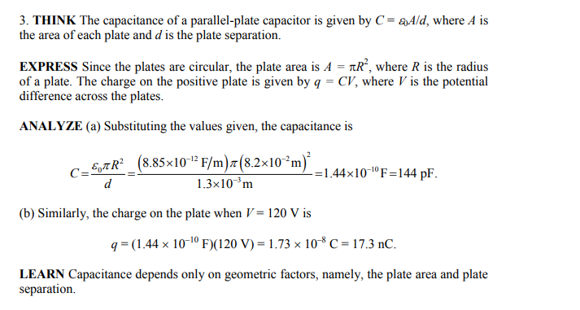

1. The plates of a spherical capacitor have radii 38.0 mm and 40.0 mm. (a) Calculate the capacitance. (b) What must be the plate area of a parallel-plate capacitor with the same plate separation and capacitance?

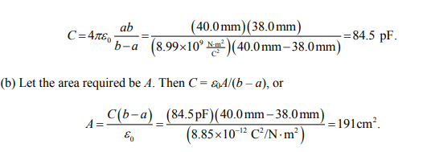

1. You have two flat metal plates, each of area 1.00 m2 , with which to construct a parallel-plate capacitor. (a) If the capacitance of the device is to be 1.00 F, what must be the separation between the plates? (b) Could this capacitor actually be constructed? 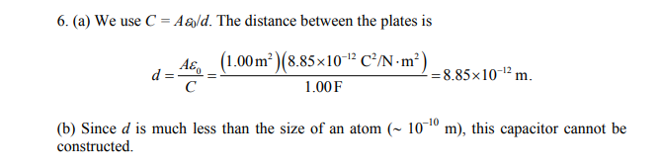
2. Each of the uncharged capacitors in Fig. has a capacitance of 25.0 µF. A potential difference of V = 4200 V is established when the switch is closed. How many coulombs of charge then pass through meter A

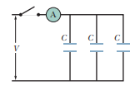

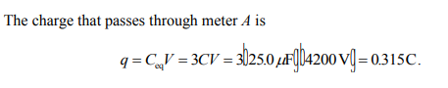

1. In Fig. find the equivalent capacitance of the combination. Assume that C1 is 10.0 µF, C2 is 5.00 µF, and C3 is 4.00 µF.

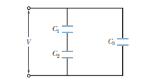

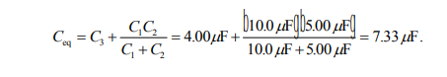

1. Evaluate the circuit shown below to determine the effective capacitance and then the charge and voltage across each capacitor.

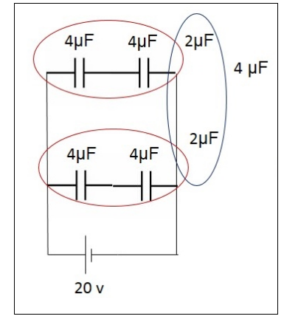

The equivalent capacitance is 4µF. Voltage across the equivalent capacitor is 20 V

This voltage is also across both of the 2 μF capacitors that were created by the series combinations in each branch.  
Find the charge on each 2 μF capacitor:  
C = Q/V  
2 μF = Q/20  
Q = 40 μC  
The 4 μF capacitors in each branch have the same charge as the 2 μF capacitors. Use this to find the voltage across each:  
C = Q/V  
4 μF = 40 μC/V  
V = 10 volts  
In summary, each of the original 4 μF capacitors have a charge of 40 μC and a voltage of 10 volts

1. Evaluate the circuit shown below to determine the effective capacitance and then the charge and voltage across each capacitor.

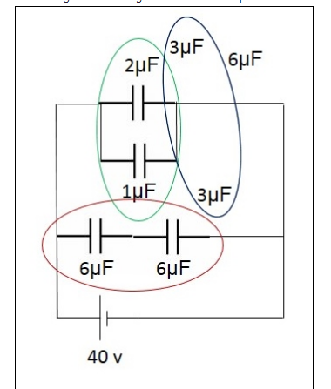

The equivalent capacitance is 6µF. The voltage across the equivalent capacitance is 40V as is the voltage across the 3 μF capacitors and is the same as the 1 μF and 2 μF capacitors.  
Find the charge on the 1 μF capacitor:  
C = Q/V  
1 μF = Q/40  
Q = 40 μC  
Find the charge on the 2 μF capacitor:  
C = Q/V  
2 μF = Q/40  
Q = 80 μC  
Find the charge on the 3 μF capacitors:  
C = Q/V  
3 μF = Q/40  
Q = 120 μC  
This is the same charge on each of the 6 μF capacitors.  
Find the voltage on each of the 6 μF capacitors:  
C = Q/V  
6 μF = 120 μC/V  
V = 20 v